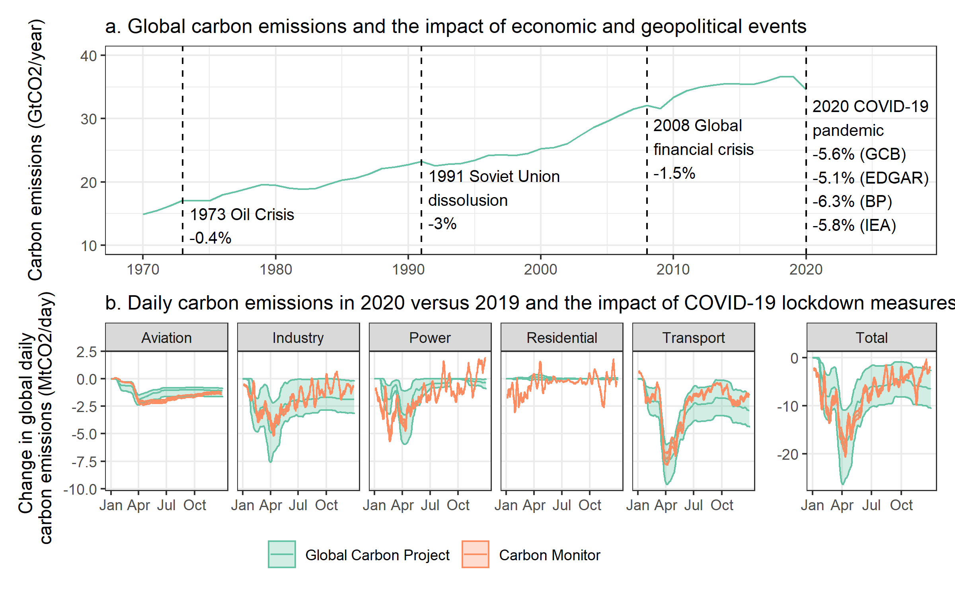

**Global fossil fuel and industry (FFI) CO2 emissions before and during the COVID-19 pandemic**. Panel a: the total trend in FFI CO2 emissions since 1970, indicating the 1 year reduction in emissions following different economic and geopolitical events. Four estimates are given for the 2020 decline in emissions, with a median value of 5.7%. Panel b: the daily perturbation in CO2 FFI emissions for different sectors, comparing 2020 and 2019. Reproduced based on Le Quere et al. (2020) and Peters et al. (2012), with additional data from Liu et al. (2020), EDGAR (2021), BP (2021) and IEA (2021).

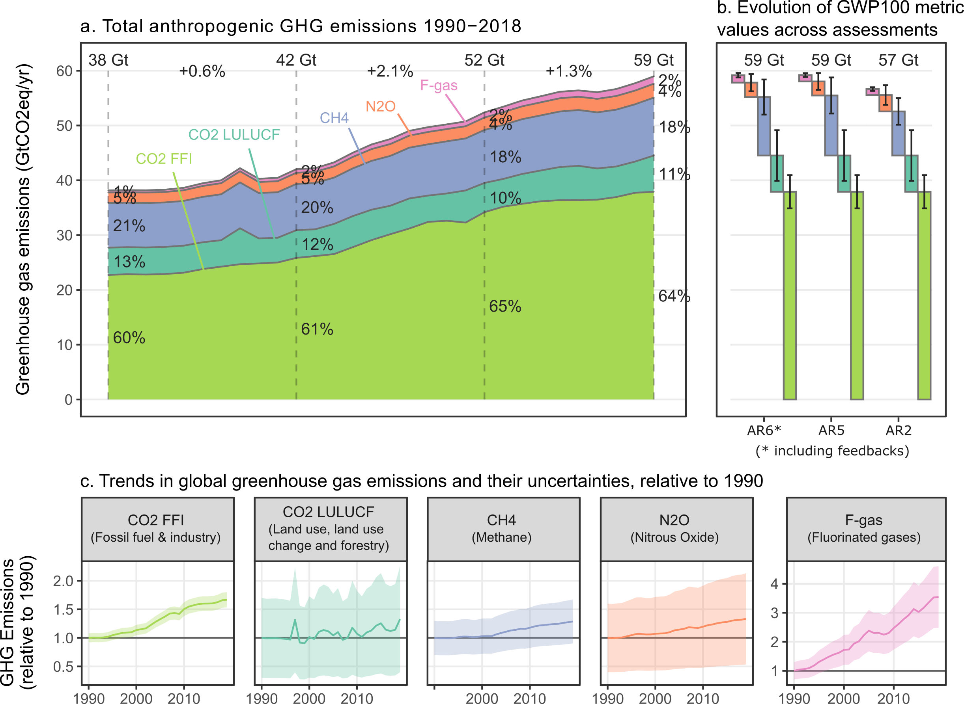

**Figure SPM.1**: Total anthropogenic GHG emissions (GtCO2-eq yr-1) 1990-2019: CO2 from fossil fuel combustion and industrial processes (FFI); CO2from Land use, land use change and forestry (CO2LULUCF); methane (CH4); nitrous oxide (N2O); fluorinated gases (F-gases). CO2LULUCF emissions are net and include gross removals as well as emissions. F-gas emissions do not include Montreal gases (CFCs, HCFCs) which reached a peak in the 1990s but have since declined. Panel a: Aggregate GHG emission trends by groups of gases reported in GtCO2-eq converted based on global warming potentials with a 100-year time horizon (GWP-100) from the IPCC Sixth Assessment Report Working Group 1 (REF Chapter 7). Panel b: Waterfall diagrams juxtaposing GHG emissions for the most recent year 2019 in CO2equivalent units using GWP-100 values from the IPCC’s Sixth, Fifth and Second Assessment Reports, respectively. Error bars show the associated uncertainties at a 90% confidence interval. Panel c: Individual trends in CO2-FFI, CO2-FOLU, CH4 and N2O emissions in (original) mass units 10 (Gt yr-1) for the period 1990–2019, normalised relative to 1 in 1990. Note the different scale for F-gas emissions compared to other gases, highlighting its very rapid growth from a low base.

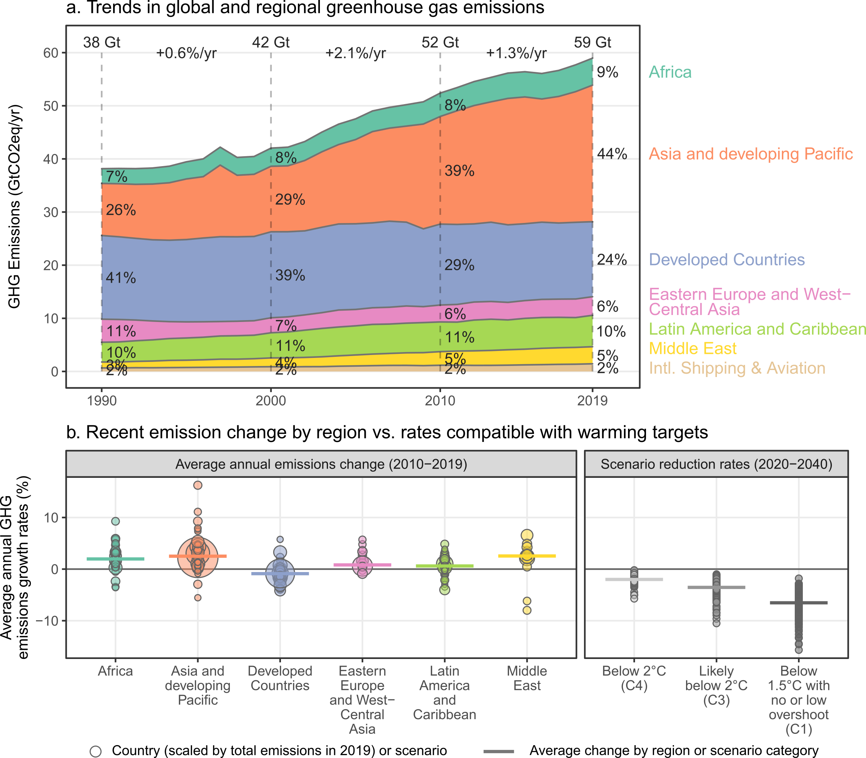

**Figure SPM.4 Change in regional GHG emissions and rates of change compatible with warming targets.** Panel a: Regional GHG emission trends (in GtCO2-eq yr-1 (GWP100 AR6)) for the time period 1990–2019. GHG emissions from international aviation (AIR) and shipping (SEA) are not assigned to individual countries and shown separately. Panel b: Historical GHG emissions change by country (2010–2019), compared to rates of reduction compatible with 1.5°C and 2°C warming targets, assessed via reduction rates in AR6 IAM scenarios over the period 2020-2040, using scenario categories C1, C3 and C4 {Table TS.1}. Individual circles depict countries (scaled by total emissions in 2019) or scenarios, horizontal lines depict the average change by region or scenario category. Panel b excludes CO2 LULUCF due to a lack of consistent national data.

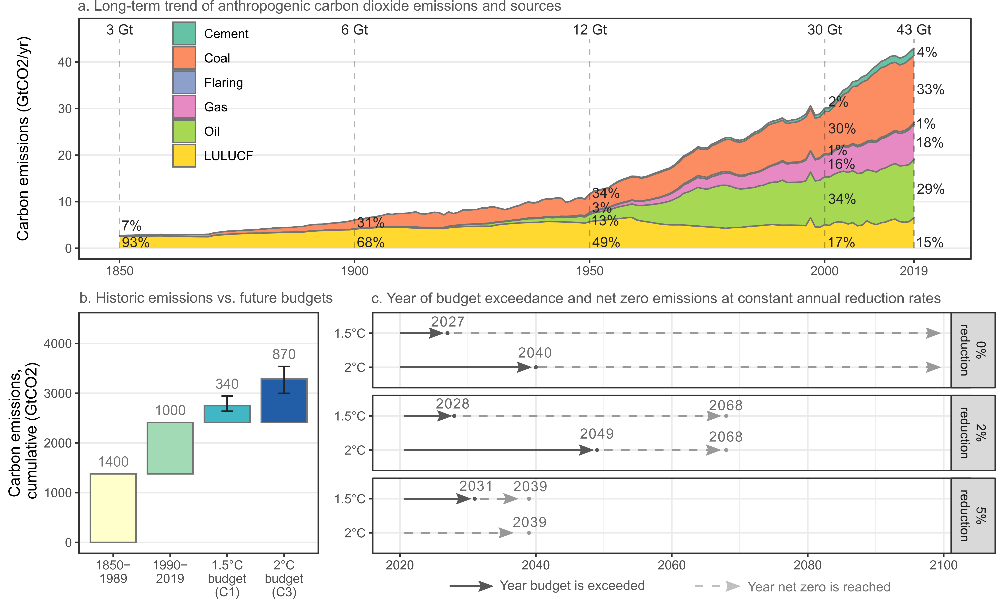

Historic anthropogenic CO2 emission and cumulative CO2 emissions (1850-2019) as well as remaining carbon budgets for 1.5°C and 2°C. Panel a shows historic annual anthropogenic CO2 emissions (GtCO2 yr-1) by fuel type and process: Land-use, land-use change and forestry (LULUCF- yellow); oil combustion (green); gas combustion (pink); gas flaring (blue); coal combustion (orange); cement production (green). Panel b shows historic cumulative anthropogenic CO2 emissions for the period 1850-1989 (yellow) and 1990-2019 (green) as well as remaining future carbon budgets as of 1.1.2020 to keep warming below 1.5°C (turquois) and 2°C (dark blue), based on the cumulative CO2 emissions to net zero emissions in AR6 scenario categories C1 and C3, respectively {TS Table 1}. The whiskers indicate the lower and upper bound budgets of 270 and 580 GtCO2 for 1.5°C scenarios, respectively, and 630 and 1170 GtCO2 for 2°C. Panel c illustrates the remaining years until the median C1 and C3 carbon budget exceedance for keeping warming below 1.5°C and 2°C respectively at a) the current levels of emissions; b) constant global annual emission reductions equal to 2% of 2019 emissions; and c) constant global annual emission reductions equal to 5% of 2019 emissions. The preliminary data indicating a substantial drop in 2020 emissions during the COVID-19 pandemic is not considered. Sources: Friedlingstein et al. (2020) and Canadell et al. (2020).